Name Kathy Mejia
Period 3
TEPAC Analytical Paragraph Activity
(Topic, Evidence, Paraphrase, Analysis, Concluding Statement)
Prompt: What is the theme of To Kill A Mockingbird and how is it developed throughout the text?
Student Response (Topic Sentence/Claim)
Sentence #1 Practice Frame:
The theme of To Kill A Mocking Bird by Harper Lee is ________________________________________________________________.
Double check that your theme statement . . .
* is a complete sentence.
* is not a cliché (def: an overused phrase or saying).
*does not specifically mention characters or events from the text.
*does not use absolute terms (e.g., always, never, all, etc.).If you believe your statement meets all of the requirements of a theme, sign your initials here ________
**Now, ask a person sitting next to you to look at your proposed theme statement and checklist. If that person agrees that your statement meets all of the requirements of a theme, ask him/her to initial here ________
If you have two sets of initials, add your revised theme statement to the top of the chart in order to create a topic sentence/claim for your TEPAC paragraph.
_____________________________________________________________________________________
*You should have used evidence from the text to determine your theme. To support the Topic Sentence/Claim of this TEPAC paragraph, you will need to cite evidence from the text. (Note: you will need at least two textual examples, but you may want to find a few extra just in case.)
*When you find a quotation you would like to use, copy it down (pay attention; you need to be an accurate transcriptionist) in the “Evidence” box (Sentence #2) in the chart.
*A note on formatting for the chart: Make sure you use quotation marks, include the page number in parentheses on which the quotation can be found, and leave your end punctuation off until after you have cited the page. It should look like this in the chart:
“We didn’t always live on Mango Street” (Cisneros 3).
Once you have decided upon the two best pieces of evidence to support your theme, you will need to complete a paraphrase and analysis sentence for each. Follow the chart as your guide.

Revised Sentence #1 (Topic Sentence/Claim)
____________________________________________________________________________________________________________________________________________________________________

Evidence (Sentence #2)  Provide one piece of evidence that illustrates (or shows to be true) your theme statement. | Paraphrase Evidence (Sentence #3)  Summarize this evidence in your own words. | Analysis of Evidence (Sentence #4)  Explain the significance of this piece of evidence, or why it illustrates the theme statement.
Evidence (Sentence #5)  Provide one piece of evidence that illustrates (or shows to be true) your theme statement. | Paraphrase Evidence (Sentence #6)  Summarize this evidence in your own words. | Analysis of Evidence (Sentence #7)  Explain the significance of this piece of evidence, or why it illustrates the theme statement. | Concluding Statement (Sentence #8)  Explain how the two pieces of evidence connect back to the topic sentence or theme/claim.
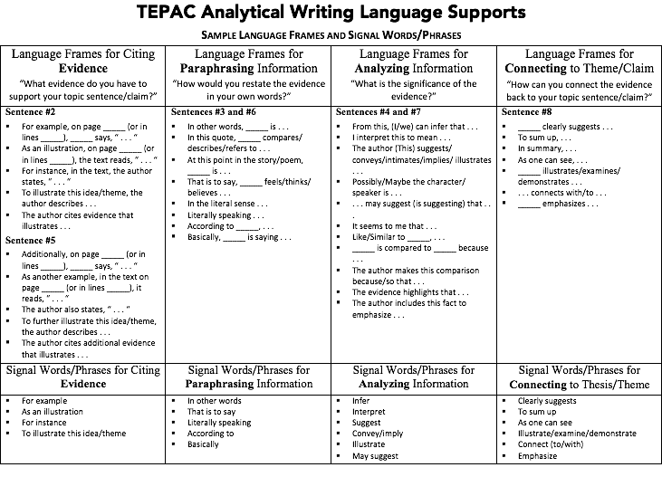

Finally, use the TEPAC Analytical Writing Language Supports handout to rewrite the paragraph using appropriate academic language frames. Don’t forget to include your topic sentence/claim (Sentence #1) in addition to all of the sentences from the chart (Sentences #2-#8).

Name ____________________________________________ Period _______
TEPAC Analytical Paragraph Rubric
(Topic, Evidence, Paraphrase, Analysis, Concluding Statement)
Required Elements: __________ / 10 (1 point each)
______ Topic sentence that answers the question at the top of the chart
______ Evidence sentence
______Paraphrase evidence sentence
______Analysis of evidence sentence
______Evidence sentence #2
______Paraphrase evidence sentence #2
______Analysis of evidence sentence #2
______Concluding statement
______Uses academic language frames
______Indents paragraph
Quality of Response
Element | A (10 points) | C (7 points) | D (6 points) | Total
Content | Paragraph thoughtfully addresses the prompt; provides accurate evidence and appropriate paraphrase and analysis. | Paragraph attempts to address the prompt; provides evidence, paraphrase, and analysis. | Paragraph may address the prompt; may provide inaccurate evidence, paraphrase, and/or analysis.
Quotations | Quotations clearly address the prompt; are accurately transcribed from the short story. | Quotations attempt to address the prompt; may be accurately transcribed from the short story. | Quotations may address the prompt; may not be accurately transcribed or may be paraphrased instead of direct quotation.  (Evidence that clearly misinterprets or misrepresents story = 0 points)
Academic Language | Paragraph appropriately utilizes sentence frames in each sentence. | Majority of paragraph appropriately utilizes sentence frames in each sentence. | Paragraph may not use sentence frames or uses them inappropriately.
Grammar | Paragraph contains few or no errors in grammar and mechanics. | Paragraph contains some errors in grammar and mechanics. | Paragraph contains many errors in grammar and mechanics.
Overall Total: __________ / 50

